|  |  |  |  |
| --- | --- | --- | --- |
| Name:  Class: | ____________________________________  ________________ | | Date: ___________ |
|  | **Year 11 Essential Mathematics**  SCORE:  /27    **Mini Test 5 2019**  **Topic – Data analysis and Displays**  ***Full working out MUST be shown to get full marks for each question.*** | | |
| **Total Time:** | 30 minutes |  | |
| **Weighting:** | 1% |
| **Equipment:** | To be provided by the student: Pen, pencil, ruler, scientific calculator,1 single sided page of A4 notes | | |

**Question 1** (3 marks)

Write which type of data the following are?

|  |  |
| --- | --- |
| 1. The length of students’ feet in cm |  |
| 1. The shoe size of students |  |
| 1. The colour of students’ shoes |  |

**Question 2** (6 marks)

The following are the disposals collected by the 2018 Brownlow medallist Tom Mitchell each round in 2018

|  |  |  |  |  |  |  |  |  |  |  |  |  |  |  |  |  |  |  |  |  |  |  |  |  |
| --- | --- | --- | --- | --- | --- | --- | --- | --- | --- | --- | --- | --- | --- | --- | --- | --- | --- | --- | --- | --- | --- | --- | --- | --- |
| Round | 1 | 2 | 3 | 4 | 5 | 6 | 7 | 8 | 9 | 10 | 11 | 12 | 13 | 14 | 15 | 16 | 17 | 18 | 19 | 20 | 21 | 22 | SF | QF |
| Disposals | 24 | 33 | 32 | 43 | 42 | 46 | 43 | 27 | 50 | 31 | 40 | 28 | 28 | 46 | 20 | 29 | 45 | 19 | 24 | 42 | 40 | 54 | 24 | 38 |

Source: <https://afltables.com/afl/stats/players/T/Tom_Mitchell.html>

1. Draw a stem and leaf plot for this data
2. Circle the median on the stem and leaf plot
3. Describe the shape of the stem and leaf plot

**Question 3** (6 marks)

The shapes of the graphs below can be described using the words “positive Skew”, Negative Skew”, “symmetrical” and “Bimodal”. Underneath each graph, write the most appropriate term.

1. 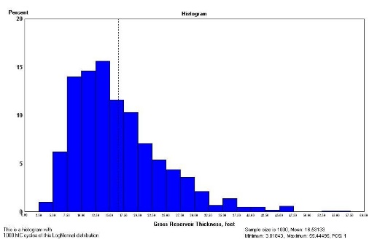 B)

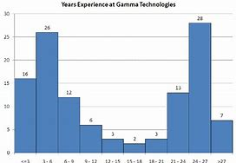

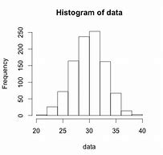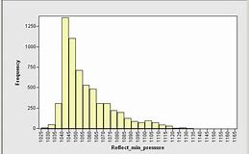

C) D)

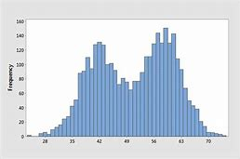 E) F)

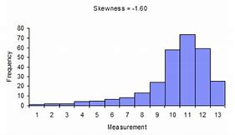

**Question 4** (6 marks)

This dot plot shows the foot length of a group of students.

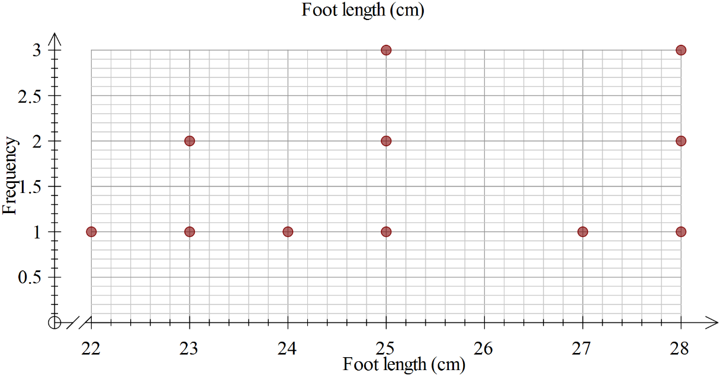

1. Calculate the range of the scores, showing your working.
2. Determine the mode.
3. Determine the median.
4. Calculate the mean, showing your working.
5. Complete this sentence: For a student in this group, you would expect them to have a foot length of about ____cm.

**Question 5** (6 marks)

Mum and Lucy were having an argument about the number of hours she spends on Facebook each night. They decided to record how many hours she spent on Facebook for one week. The results are shown below.

|  |  |  |  |  |  |  |  |
| --- | --- | --- | --- | --- | --- | --- | --- |
| **Day** | **Mon** | **Tues** | **Wed** | **Thurs** | **Fri** | **Sat** | **Sun** |
| **Hours on Facebook** | 4 | 2 | 2 | 1 | 6 | 4 | 8 |

1. Find the mode, median and mean for this data.
2. Which of these measures could Mum use to demonstrate that Lucy spends too long on

Facebook? Explain your reasoning.

1. Which of these measures could Lucy use to show that she doesn’t spend too much time on Facebook? Explain your reasoning.